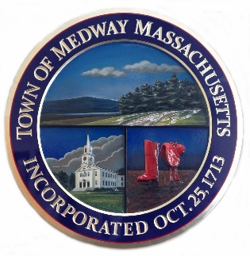

#29-25

TOWN OF MEDWAY

PER-DIEM PARAMEDIC AND PER-DIEM FIREFIGHTER/PARAMEDIC

The Town of Medway seeks qualified applicants for the per-diem positions of Paramedic and Firefighter/Paramedic. Responsibilities include responding to medical emergencies, fire suppression, fire prevention, and station duties, as applicable to the role.

Minimum Qualifications for Paramedics:

- Must be at least eighteen (18) years of age.
- Must possess a high school diploma or equivalent.
- Must possess a valid driver’s license with a clean driving record.
- Must possess an active Paramedic license issued by the Massachusetts Department of Public Health.
- Must have the ability to pass Criminal Offender Record Information (CORI) check, comprehensive physical exam, and drug test.

Minimum Qualifications for Firefighter/Paramedics:

- Must be at least eighteen (18) years of age.
- Must possess a high school diploma or equivalent.
- Must possess a valid driver’s license with a clean driving record.
- Must possess an active Paramedic license issued by the Massachusetts Department of Public Health.
- Firefighter I/II certified through an approved firefighting training academy.
- Must have the ability to pass Criminal Offender Record Information (CORI) check, comprehensive physical exam, and drug test.

This is a per-diem health and welfare benefits-eligible* non-union position.

Pay Scale

Years of Paramedic Experience Hourly Rate

Entry-Level (0–1 years) $28.00/hr.

Intermediate (1–5 years) $32.00/hr.

Experienced (5+ years) $36.00/hr.

Firefighter/Paramedic Differential

Personnel who are certified and approved to function in a dual-capacity role as Firefighter/Paramedics shall receive an additional $2.00 per hour above their base paramedic rate:

Years of Experience FF/Paramedic Rate

0–1 years $30.00/hr.

1–5 years $34.00/hr.

5+ years $38.00/hr.

The position will remain open until filled.

Please email your application and resume to choule@medwayma.gov or mail it to the Human Resources Manager, Town Hall, 155 Village Street, Medway, MA 02053. The application can be found here. Application

- There are minimum shift requirements to maintain benefit eligibility.

The Town of Medway is an Equal Opportunity Employer.

